Book

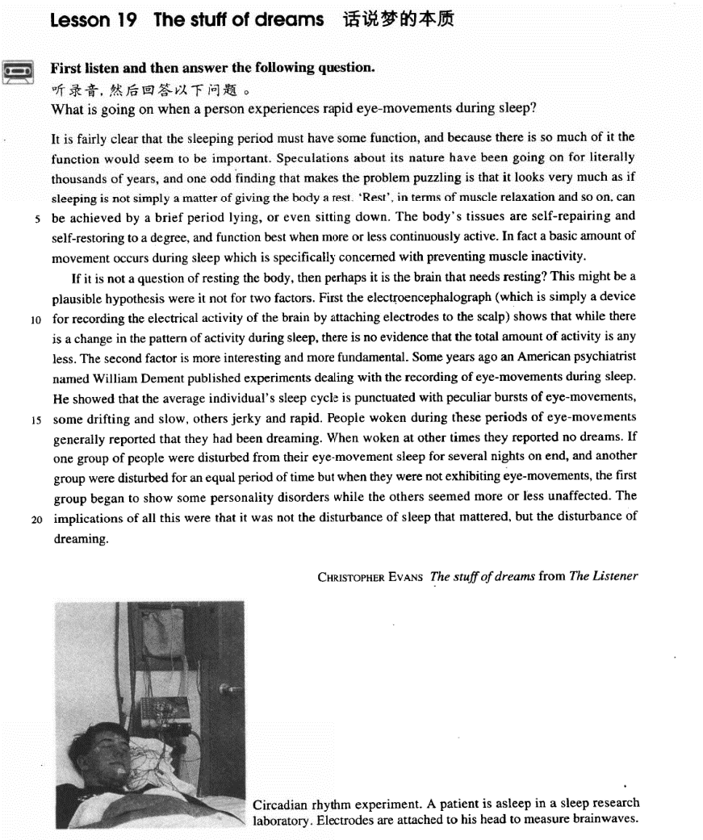

课文

It is fairly clear that the sleeping period must have some function, and because there is so much of it the function would seem to be important.

很清楚，睡眠必然具有某种作用。睡眠占去那么多时间，所以其作用似乎还是很重要。

Speculations about its nature have been going on for literally thousands of years,

人们对睡眠作用的种种猜测，确实有数千年之久。

and one odd finding that makes the problem puzzling is that it looks very much as if sleeping is not simply a matter of giving the body a rest.

一项使人对这个问题感到困惑的奇怪的发现是，睡眠在很大程度似乎并不仅仅是为了使身体得到休息。

'Rest', in terms of muscle relaxation and so on, can be achieved by a brief period lying, or even sitting down.

“休息”，从使肌肉得到放松等方面来看，只要稍微躺一躺，甚至坐一坐就能达到。

The body's tissues are self-repairing and self-restoring to a degree, and function best when more or less continuously active.

人体组织在一定程度上有自我修补和自我恢复的能力，有张有弛地连续活动时，其功能最佳。

In fact a basic amount of movement occurs during sleep which is specifically concerned with preventing muscle inactivity.

事实上，睡眠状态下仍有着基本的活动量，以防止肌肉活动停止。

If it is not a question of resting the body, then perhaps it is the brain that needs resting?

如果睡眠的功能不是在于使身体得到休息，那么也许是让大脑得以休息？

This might be a plausible hypothesis were it not for two factors.

若不是下面两点，这种假使似乎是有道理的。

First the electroencephalograph (which is simply a device for recording the electrical activity of the brain by attaching electrodes to the scalp) shows that while there is a change in the pattern of activity during sleep,

第一点，脑电图记录仪显示，人在睡眠时大脑活动的方式有变化，但没有迹象表明，其活动总量有任何减少。

there is no evidence that the total amount of activity is any less. The second factor is more interesting and more fundamental. Some years ago an American psychiatrist named William Dement published experiments dealing with the recording of eye-movements during sleep.

第二点更有意思，也更重要。前些年，美国一位精神病学者发表了一篇报告，报告中记录了眼球在睡眠时的活动情况。

He showed that the average individual's sleep cycle is punctuated with peculiar bursts of eye-movements, some drifting and slow, others jerky and rapid.

他指出，平常人的睡眠周期中不时伴有一阵阵奇怪的眼球队活动，这些活动有的飘忽而缓慢，有的急剧而快速。

People woken during these periods of eye-movements generally reported that they had been dreaming.

在眼球活动期间被叫醒的人都说自己在做梦；

When woken at other times they reported no dreams.

在其他期间叫醒他们，则说没有做梦。

If one group of people were disturbed from their eye-movement sleep for several nights on end,

如果有两组人，一组人连续几夜在眼球队活动时被叫醒；

and another group were disturbed for an equal period of time but when they were not exhibiting eye-movements,

另一组人也是连续几夜被叫醒，但是在眼球队没活动时被叫醒的。

the first group began to show some personality disorders while the others seemed more or less unaffected.

结果，第一组人开始出现性格失常，而第二组人似乎没受什么影响。

The implications of all this were that it was not the disturbance of sleep that mattered, but the disturbance of dreaming.

这一切暗示我们：睡眠受到干忧没关系，而做梦受到干忧是有问题的。

词汇讲解

Lesson 19 The stuff of dreams

speculation [7spekju'leɪʃn]

n. 推测；投机

speculation

conjecture

guesswork / guess work

She dismissed the newspaper reports as pure speculation.

There has been a great deal of speculation *about* what will happen after the elections.

speculation *in* property development speculate v. 1. 猜测

We can only speculate *on* the reasons for his sudden resignation.

speculate v. 2. 投机

He speculated *in* stocks. speculative adj. 猜测的；投机的

His conclusions are purely speculative.

Beyond two or three days, the world's best weather forecasts are speculative, …

speculative investments

“spec(t)” / “spi(c)” = to see; to look speculate speculation speculative

inspect inspector inspection suspect suspicious suspicion

expect expectation expectancy

respect respectable respectful introspect retrospect perspective

|  |  |  |
| --- | --- | --- |
| circumspect |  | circumspection |
| spectacle | spectacular | specious |
| despise | espionage | conspicuous |

literally ['lɪtərəli]

adv. 多达，长达，足足有； 逐字地，字面地literally adv. 1. used to emphasize that sth, especially a large number, is actually true （加强语气）多达，长达，足足有……

The Olympic Games were watched by literally billions of people.

Now there are literally thousands of companies using our software. literally adv. 2. If a word or expression is translated literally, its most simple or basic meaning is translated 字面地，逐字地

The word 'planet' literally means 'wandering body'.

Idioms usually cannot be translated literally into another language.

literal adj. the literal meaning of a word or expression is its basic or original meaning 字面的，逐字的

The literal meaning of 'television' is 'seeing from a distance'.

literal translation liberal translation

|  |  |  |
| --- | --- | --- |
| “liter” = letter |  | |
| literal literally | literary | literature |
| literate literacy | illiterate | illiteracy |

plausible ['plɔ:zəbl]

adj. 合理的，可信的，可能正确的plausible adj. reasonable and likely to be true a plausible explanation / excuse

His story certainly sounds plausible. plausibility n. [U] 合理，可信

This new evidence lends plausibility to the theory that she was murdered.

|  |  |  |
| --- | --- | --- |
| reasonable | believable | credible |
| convincing | persuasive | cogent |

implausible adj. 难以置信的，不太可能是真的

a highly implausible claim / idea / theory

Her explanation is not implausible. unbelievable incredible unconvincing

improbable inconceivable unlikely preposterous shaky lame hypothesis [haɪ'pɒθəsɪs]

n. 假说，假设

hypothesis n. an idea that attempts to explain something but has not yet been tested or proved to be correct 假说，假设

to formulate / confirm a hypothesis

a hypothesis *about* the function of dreams

There is little evidence to support these hypotheses (pl. [hai'pɔθisiːz]). axis → axes basis → bases

oasis → oases crisis → crises analysis → analyses

synopsis → synopses diagnosis → diagnoses parenthesis → parentheses

psychiatrist [sai'kaiətrist]

n. 精神病医生，精神病学家

psychiatrist n. a doctor who studies and treats mental illnesses 精神病医生，精神病学家

psychiatry n. [U] study and treatment of mental illness 精神病学，精神病治疗

psychiatric adj. relating to the study and treatment of mental illness 精 神病学的；治疗精神病的

a psychiatric clinic psychiatric treatment

Charles was suffering from a psychiatric disorder.

This result merely confirms earlier American and British studies: if there is any effect of noise upon mental health, it must be so small that present methods of psychiatric diagnosis cannot find it.

“psych(o)” = soul

psychiatry psychiatric psychiatrist psychology psychological psychologist psychoanalysis psychoanalyze punctuate ['pʌŋktʃueɪt]

v. 加标点；不时打断，穿插

The children have not yet learned to punctuate correctly. The transcription of his speech must be punctuated.

be punctuated by / with sth.

Her speech was punctuated by bursts of applause. The silence was occasionally punctuated by laughter.

He showed that the average individual's sleep cycle is punctuated with peculiar bursts of eye-movements, …

“punct” = to prick

punctuate punctuation punctual punctuality

puncture acupuncture

stuff n. fundamental material 基础材料，本质

the stuff of greatness

Real life is the stuff of all good novels. We must find out what stuff he is made of.

It is fairly clear that sleeping period must have some function, and

*because there is so much of it* the function would seem to be important. it is fairly clear that …

it is as clear as daylight that …

It was as clear as daylight then that burglars had forced an entry during her absence.

it is obvious that …

The rope had been cut, so it was obvious that the lamb had been stolen. it becomes apparent that …

It later became apparent that rabbits were developing a degree of resistance to this disease, so that the rabbit population was unlikely to be completely exterminated.

would seem / appear

It would seem more sensible to apply standards flexibly rather than rigidly.

A more plausible explanation would seem to be that people are fed up with the Conservative government.

It would appear that the legal profession is the nearest thing to a

recession-proof industry.

Time would appear to be the significant factor in this whole drama. That would be his mother.

—Who is the man you want to speak to?

—You wouldn’t know him.

He would have reached New York.

Speculations *about its nature* have been going on for literally thousands of years, and one odd finding that makes the problem puzzling is *that it looks very much as if sleeping is not simply a matter of giving the body a*

*rest*.

Speculations about … have been going on for literally thousands of years.

造句：对于宇宙起源的猜测已经持续长达数千年了。

Speculations about the origins of the universe have been going on for literally thousands of years.

造句：除夕 (Lunar New Year’s Eve) 放鞭炮 (let off firecrackers) 的习

俗已经持续长达数千年了。

The custom of letting off firecrackers on Lunar New Year’s Eve has been going on for literally thousands of years.

finding n. information that is discovered as the result of research 研究结

果

These findings suggest that there is no direct link between unemployment and crime.

It looks very much as if … 看上去很可能……

It looked very much as if teeth, and not an axe, had cut down that tree.

It looks very much as if the 19-year-old Chinese player will regain the title she first won at sixteen.

be simply a matter of doing 不过是……的事儿/问题

Success in business is simply a matter of knowing when to take a chance. be not simply a matter of doing 不仅仅是……的事儿/问题

Reducing the number of road deaths is not simply a matter of improving

roads.

a / the matter / question of …

……的事儿/问题

… but as soon as the question of prestige arises, … It is a question of pride as much as anything else.

If it is not a question of resting the body, then perhaps it is the brain that needs resting?

Education in the wilderness is not a matter of monetary means.

These are partly a matter of personal circumstances, partly a matter of psychology.

'Rest', *in terms of muscle relaxation and so on*, can be achieved by a brief period lying, or even sitting down.

The body's tissues are self-repairing and self-restoring to a degree, and

function best when more or less continuously active.

self- *prefix* by yourself or by itself a self-propelled vehicle

self-closing doors

a self-cleaning oven a self-winding watch

to a (certain) degree / to some degree = partly To a degree, it is possible to educate oneself.

We're all willing to support him to a certain degree.

Disillusionment with the parents, however good and adequate they may be both as parents and as individuals, is to some degree inevitable.

to a (certain) extent / to some extent = partly

We all to some extent remember the good times and forget the bad. I do agree with him to an extent.

I agree with you to a certain extent, but ...

One of the things that fascinates us *most* about cats is the popular belief that they have nine lives.

Those who work *(the) most* often get paid *(the) least*. more or less adv. almost

a place where the ground was more or less flat They've settled here more or less permanently. He more or less admitted he'd done it.

… the first group began to show some personality disorders while the others seemed more or less unaffected.

continuously continually

He has lived and worked in France almost continuously since 1961. They're continually arguing.

These lights flickered continuously like traffic lights which have gone mad.

Everything around him was full of her presence, continually reopening the wound.

In fact a basic amount of movement occurs during sleep which is specifically concerned with preventing muscle inactivity.

specifically adv. relating to or intended for one particular type of person or thing only 特定地，专门地

liquid vitamins specifically designed for children

a magazine aimed specifically at working women (be) specifically designed for …

(be) aimed specifically at …

(be) specifically concerned with … concern …

be concerned with …

The book concerns music.

The book is concerned with music.

a book concerning music

a book concerned with music concern …

be concerned about …

What concerns me is our lack of preparation for the change. The police said they were very concerned about the boy's safety.

inactivity n. [U] the state of not doing anything, not moving, or not working

Don't suddenly take up violent exercise after years of inactivity.

If it is not a question of resting the body, then perhaps it is the brain that

needs resting?

rest v. to not use a part of your body that is tired or injured so that it can get better

Rest *your eyes* every half an hour. I need to sit down and rest *my legs*.

need / require / want *doing / to be done*

The watch needs / requires / wants *mending / to be mended*.

… then perhaps it is the brain that needs *to be rested*?

造句：如果不是更换贸易伙伴的问题，那可能需要更换的就是贸易标准了。

If it is not a question of replacing trading partners, then perhaps it is trading standards that need replacing.

This might be a plausible hypothesis were it not for two factors. This might be a plausible hypothesis if it were not for two factors.

Insects would make it impossible for us to live in the world; they would devour all our crops and kill our flocks and herds, if it were not for the protection we get from insect-eating animals.

This might be a plausible hypothesis if it were not for two factors. This might be a plausible hypothesis but for / except for two factors.

与 现 在 事 实 相 反 ：

If + S. + did / were, S. + would / should / could / might + do

与 过 去 事 实 相 反 ：

If + S. + had done, S. + would / should / could / might + have done

与 未 来 趋 势 相 反 ： If + S.+ should do, S.+ would / should / could / might + do If + S.+ did / were to do, S.+ would / should / could / might + do

were had should If I were you, I would go abroad at once.

Were I you, I would go abroad at once.

If you had come here a little earlier just now, you might have met her. Had you come here a little earlier just now, you might have met her.

The cave might never have been discovered had not the entrance been spotted by the distinguished French pot-holer, *Berger*.

The cave might never have been discovered if the entrance had not been spotted by the distinguished French pot-holer, Berger.

If it should rain tomorrow, you could stay at home. Should it rain tomorrow, you could stay at home.

If the sun were to rise in the west, I would lend you the money. Were the sun to rise in the west, I would lend you the money.

The millions of calculations involved, had they been done by hand,

all practical value by the time they finished.

(A) could lose (B) would have lost

(C) might lose (D) ought to have lost

First the electroencephalograph *(which is simply a device for recording the electrical activity of the brain by attaching electrodes to the scalp)* shows that while there is a change in the pattern of activity during sleep, there is no evidence *that the total amount of activity is any less*. electroencephalograph

*“electr”* = electron + *“encephalo”* = brain + *“graph(y)”* = to write bovine spongiform encephalopathy (BSE)

|  |  |  |
| --- | --- | --- |
| photograph | telegraph | autograph |
| geography | biography | autobiography |
| demography | bibliography | calligraphy |

device for doing sth. / to do sth.

a device for measuring humidity in the air

a device to detect carbon monoxide attach … to …

Lined up against the wall, there were long thin wires attached to metal spheres.

The sides of the dish were so smooth that it was almost impossible to attach hawsers and chains to the rim without damaging it.

be sentimentally attached to …

She was sentimentally attached to this house, for even though it was far too big for her needs, she persisted in living there long after her husband's death.

There is some evidence that the economy is improving.

Is there any scientific evidence that a person's character is reflected in their handwriting?

There is now clear evidence that these chemicals are damaging the environment.

any adv. used before the comparative form of an adjective or adverb to mean ‘even a small amount’ 一点儿，丝毫

I can't run any faster.

Are you feeling any better?

Some years ago an American psychiatrist *named William Dement* published experiments dealing with the recording of eye-movements during sleep.

deal with: if a book, speech etc. deals with a particular subject, it is about that subject 关于

The story deals with the psychological conflicts between mother and son.

concern / be concerned with …

Much of the material in her early letters concerns events which happened some years before.

Elton's books are often concerned with environmental issues.

In fact a basic amount of movement occurs during sleep which is specifically concerned with preventing muscle inactivity.

One case concerns and eleven-year-old schoolgirl, Vera Petrova, who has normal vision but who can also perceive things with different parts of her skin, and through solid walls.

A recent case concerns Jane Butlin whose fiancé, John, runs a successful furniture business.

be about …

Have you ever read 'Hideous Kinky'? It's about an English woman and her daughter travelling in Morocco.

focus on …

The next chapter will focus on this problem in greater detail.

a weekly magazine mainly focusing on business-related issues

He showed that the average individual's sleep cycle is punctuated with peculiar bursts of eye-movements*, some drifting and slow*, *others jerky*

*and rapid*.

burst n. a short period of a particular activity or strong emotion that often starts suddenly 一阵

a sudden burst of activity / energy / anger / enthusiasm

spontaneous bursts of applause

A burst of activity associated with the laying of submarine cables soon confirmed the challenger's observation that many parts of the ocean were two to there miles deep, and the existence of underwater features of considerable magnitude.

He showed that the average individual's sleep cycle is punctuated with peculiar bursts of eye-movements*, some being drifting and slow*, *others*

*being jerky and rapid*.

drift v. to move, change, or do sth. without any plan or purpose 漫 无 目标地移动、改变等

The crowds drifted away from the stadium. Jenni spent the year drifting around Europe.

jerky adj. making sudden starts and stops and not moving smoothly 忽动

忽停的，颠簸不稳的

The disease causes sudden jerky movements of the hands and legs. People woken during these periods of eye-movements generally reported *that they had been dreaming*.

When (they were) woken at other times they reported no dreams.

If one group of people were disturbed from their eye-movement sleep *for several nights on end*, and another group were disturbed *for an equal period of time but when they were no exhibiting eye-movements*, the first group began to show some personality disorders while the others seemed more or less unaffected.

on end = in a row = successively

Some plays are so successful that they run for years on end. She's been voted Best Actress three years in a row.

She rearranged the chapters of her book.

She assured him that the chapter was finished.

She worked on the chapter for quite a while.

She wasn't sure how to end the book.

W: Did Linda ever finish that introductory chapter? M: I'm not sure. She's spent hours on end rewriting it. Q: What does the man imply about Linda?

Answer: (C) She worked on the chapter for quite a while.

She wishes the rain would stop soon.

She doesn’t care about the weather.

She’ll go out after the rain stops.

She expects it to rain for four more days.

M: It’s raining again.

W: This makes it four days in a row. Do you think it’ll ever stop?

Q: What does the woman mean?

Answer: (A) She wishes the rain would stop soon.

exhibit v. (fml.) to show a particular feeling, quality, ability, or form of behavior 表现，显示，显出

She's beginning to exhibit symptoms of stress.

The patient exhibited signs of fatigue and memory loss. disorder n. 1. 混乱，骚乱

disorder n. 2. an illness of the mind or body 疾病，不适，障碍

He's suffering from severe mental disorder. He had treated her for a stomach disorder.

unaffected (by …) adj. not changed or influenced by sth 未改变的，未受

影响的

People's rights are unaffected by the new law.

The children seem unaffected emotionally by their parents’ divorce.

The implications of all this were that it was *not* the disturbance of sleep that mattered, *but* the disturbance of dreaming.

If there is one—which I take leave to doubt—then it is older people who create it, not the young themselves.

If this facilitates forgery, it is the bank which will lose, not the customer. But the significant thing is not the behaviour of the players but the attitude of the spectators: …

it is not … that matters, but ...

it is … that / who / which …, not … the significant thing is not … but …

… it was not the disturbance of sleep that mattered, but the disturbance of dreaming.

… it was the disturbance of dreaming that / which mattered, not the disturbance of sleep.

… the significant thing was not the disturbance of sleep but the disturbance of dreaming.

… the significant thing is not the behaviour of the players but the attitude of the spectators …

… it is not the behaviour of the player that matters, but the attitude of the spectators …

… it is the attitude of the spectators that matters, not the behaviour of the players …

digestive